**Table of Contents**



**FPT International School**

--- o0o ---

**PROJECT REPORT**

**HTML5 – TRYM GYM**

**Course / Module :** Project S1

Batch: **T1804E**

Semester: 1

Group:

1. Nguyen Thanh Tung - D00762
2. Hoang Van Quynh - D00730
3. Duong Tuan Linh - D00772

Faculty: Bui Thi Oanh

**Hanoi - 10/2018**

1. Problem Definition 3

i. Introduction 3

ii. Implementation Environment 4

User Stories 5

User type (Example: Customer) 5

Story 1 : View 5

Besides, customers can: 5

- Learn the exercises to increase the muscles of the chest, muscles,… 5

Story 2: Feedback 5

Customers can report, feedback on the quality of service, the quality of training conditions and all related 5

2. View model 5

5

3. UI\UX 6

3.1 GUI 1 - HOME 6

3.2 GUI 2 – ABOUT US 8

3.3 UI 3 – CLUB 10

3.4 GUI 4 - TRAINER 16

3.5 GUI 5 – LIBRARY 18

3.6 UI 6 – CONTACT US 25

3.7 GUI 7 – TRY REGISTER 26

3.8 GUI 8 – FEEDBACK 27

4. Summary 28

# Problem Definition

### Introduction

In 2007, TRYM-GIM became the first and largest international fitness company in America. With the mission of "Make Life Better", TRYM-GYM is not just like normal gym. This is the heart of dynamic lifestyle, to inspire, bring joyful fun as well as new vitality for the community.

This is where convergence of exercise, fashion and entertainment in a healthy environment, full of energy. From music and light to modern equipment and world-class coaches, every detail is meticulously prepared to provide a positive and positive experience. Best for customers. The success of TRYM-GYM is linked to the vision and leadership of its founder and CEO, Randy G. Dobson. Randy has blown his passionate company of life and entertainment, which has revolutionized the way fitness is practiced throughout Europe.

The members of TRYM-GYM's senior management team have been extremely important to the development of some of the top fitness brands, such as 24 Hour Fitness, California Fitness, Jackie Chan Sport, UFC Gyms, Crunch Fitness, and Les Mills.

With a combined board of over 30 years of experience in dozens of different countries, TRYM-GYM has owned and is one of the most experienced and professional leaders in the fitness industry. This is also the main reason TRYM-GYM is loyal and consistent in implementing the brand's commitment to make life better.

Trim-Gym is 35 years old fitness centre. Fitness fads come and go, and we have learned what is classic and has longevity: a commitment to serving others. We have decided to come up with our website. It will provide all information about us to our clients and fitness freak people.

A website needs to be designed to details of various locations of our fitness centres, types of services we offer and various instruments available with us.

The website is to be developed for the Windows Platform using HTML5, JavaScript and Geolocation. The site should work well in all leading browsers including Chrome, IE, Firefox etc.

**Requirement Specification:**

Trym-Gym site is to be created based on the following requirements.

1. The Home Page should be created with a suitable logo, the header section can be added which will show various fitness images.
2. The site must contain the links to navigate through various fitness therapy.
3. Site should have different section for Men and Women and display fitness programs accordingly.
4. Various exercises must be categorized like (Cardio, Muscle, ABS, Arms etc.)
5. Details and Guidelines should be provided for each type of workout/exercise.
6. Website should provide section for various Nutrition plans offered in the Gym.
7. Training Cost should be provided for various plans offered.
8. Website should provide list of all branches with proper address and location map.
9. Gallery section should be added for viewing different images.
10. Feedback must be allowed to enter by the viewer
11. Site map, Gallery, about us, Queries link.
12. There should be a “Contact Us” page which will have the Address of the Company which should be displayed using GeoLocation API (eg. GoogleMaps) and the email address which when clicked will invoke the local mail client from where they can send an email.
13. The complete description must be allowed to get download as pdf or doc file.
14. The advertise section with various facilities provided should be mentioned.

### Implementation Environment

* Notepad++ /HTML editor
* Google Chrome
* Adobe Photoshop CS6

# User Stories

## User type (Example: Customer)

### Story 1 : View

Users can search:

* Tranner infomation
* Course information
* The nearest club

### Besides, customers can:

### Learn the exercises to increase the muscles of the chest, muscles,…

* Route set
* Nutrition to have a perfect body

### Story 2: Feedback

### Customers can report, feedback on the quality of service, the quality of training conditions and all related

# 

# View model

Home

Curent Events

Contact Us

Trainer

Library

Schedule

Club

About Us

Information about the coaches

About the Trym Gym, the history of formation

Information on existing offices

Schedule

information for students

Send information for advice

Experience about: cardio, muscle, nutrition and galery

# UI\UX

## GUI 1 - HOME

Example 1: Home

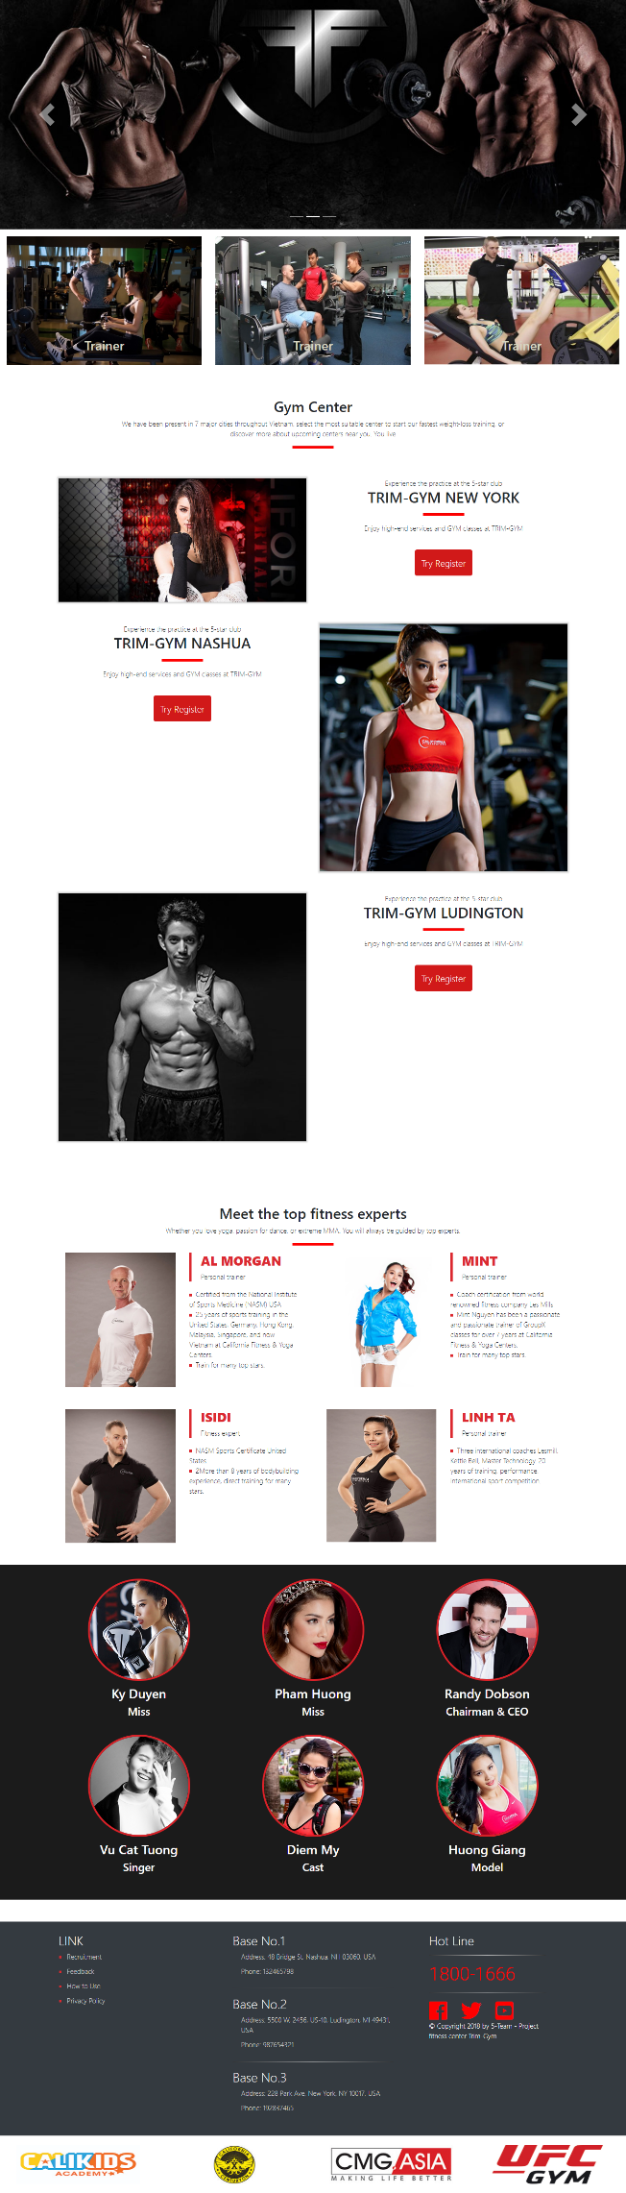

## GUI 2 – ABOUT US

Example 1: ABOUT US

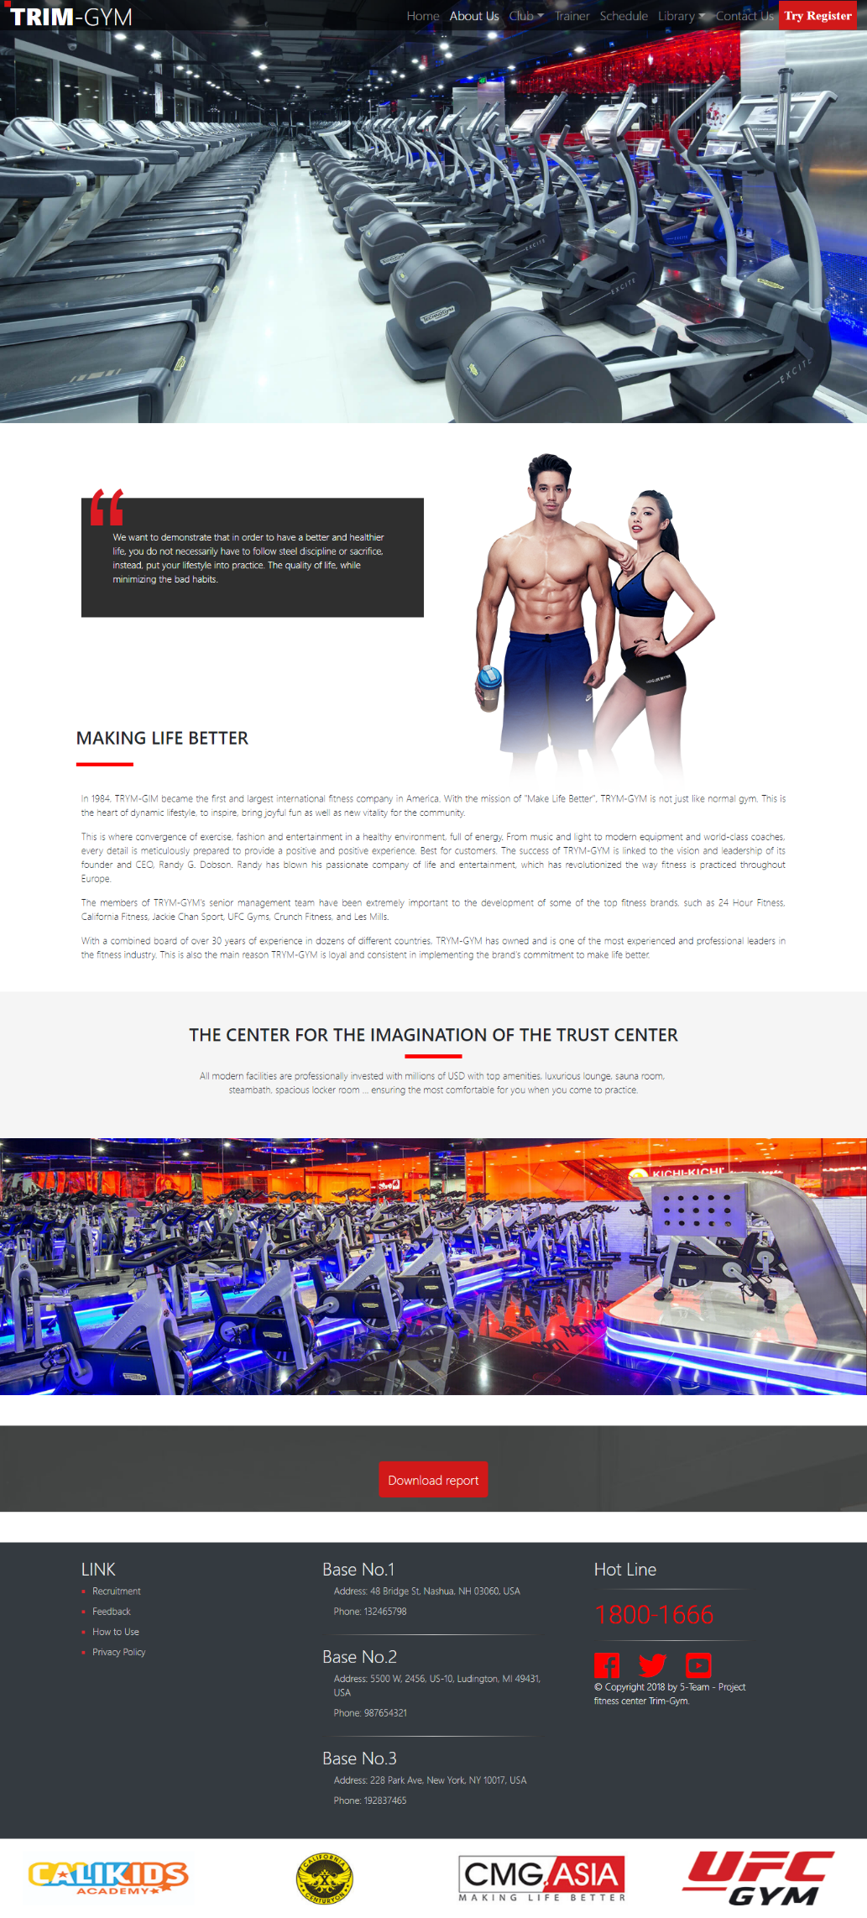

## UI 3 – CLUB

Example 1 : NASHUA

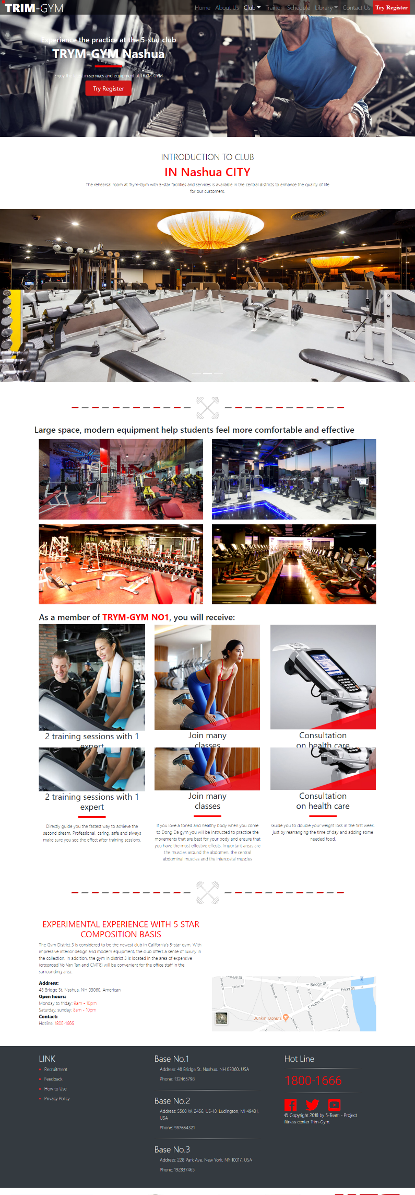

Example 2 : LUDINGTON

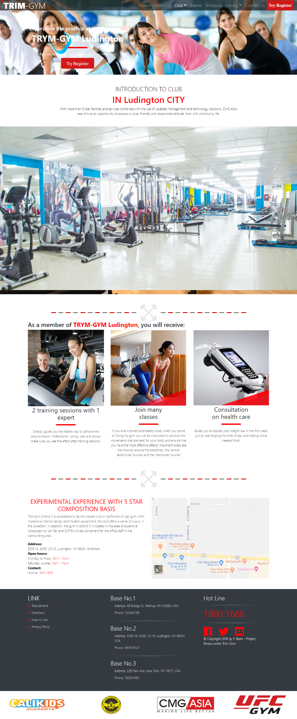

Example 3 : NEW YORK

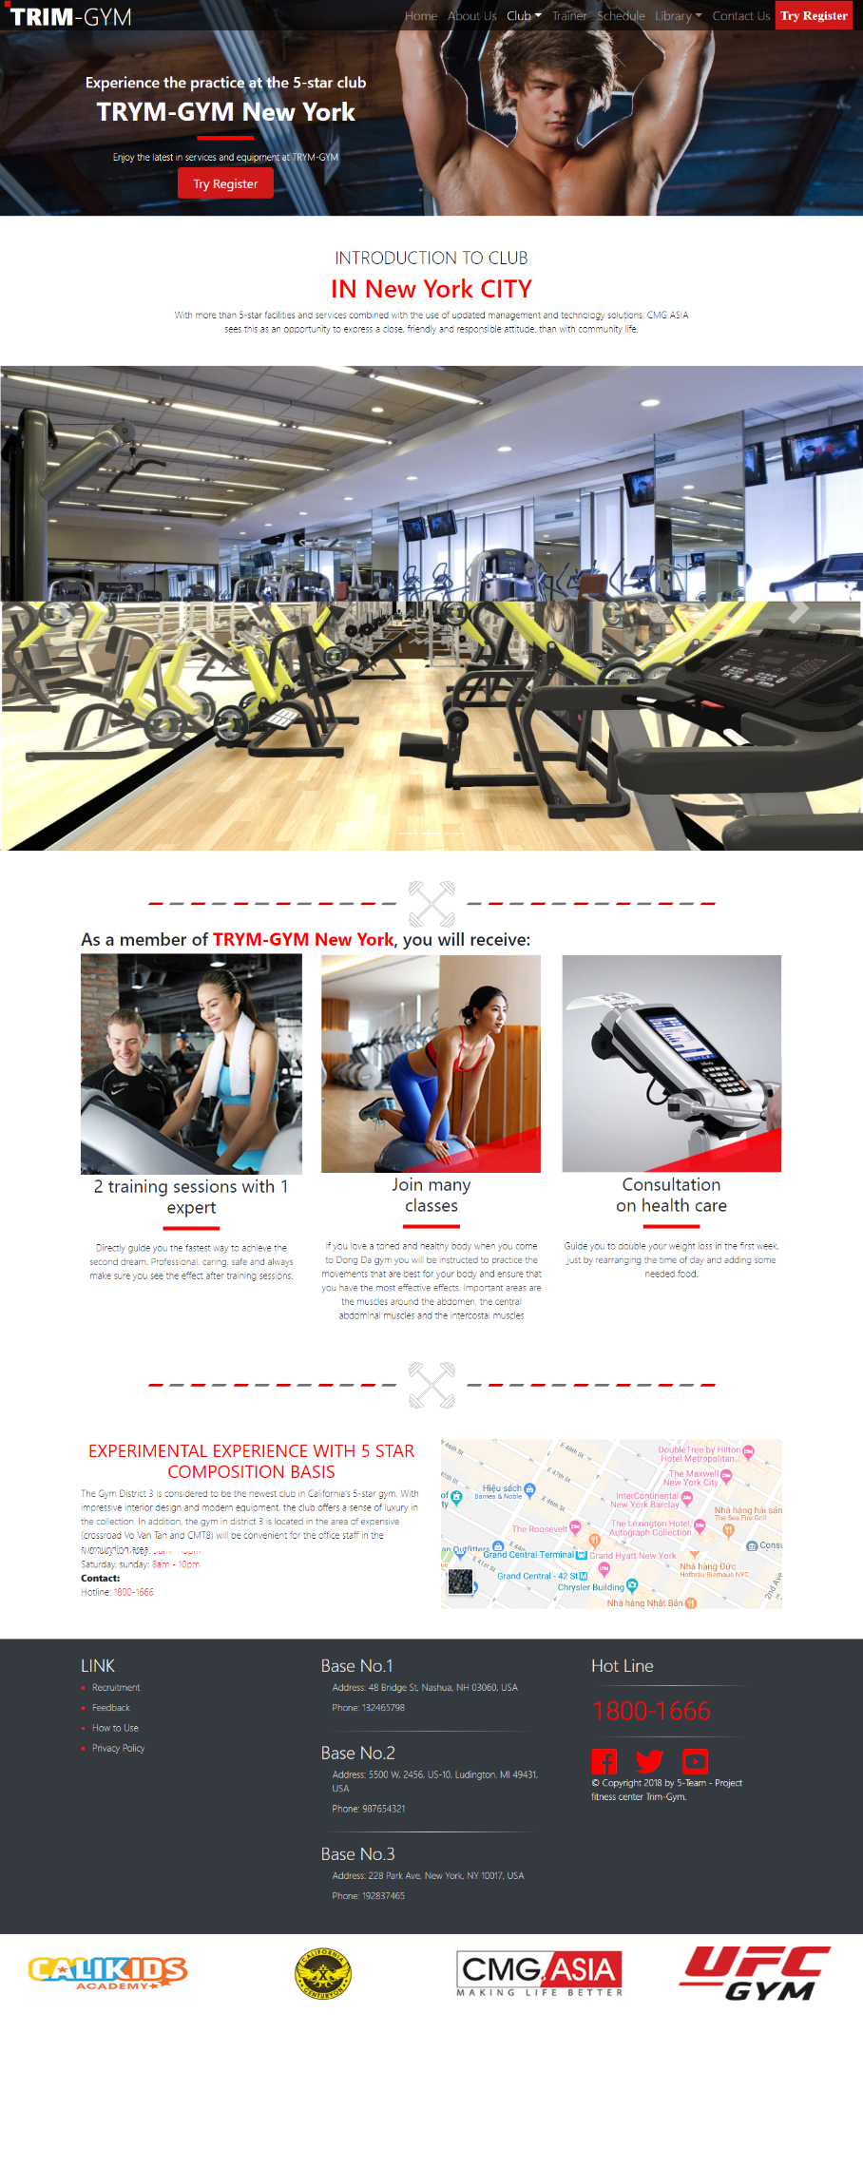

## GUI 4 - TRAINER

Example 1: TRAINER

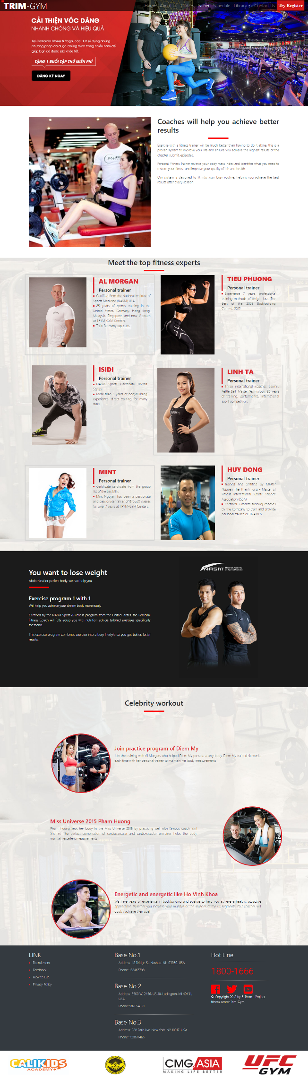

## GUI 5 – LIBRARY

Example 1: CARDIO

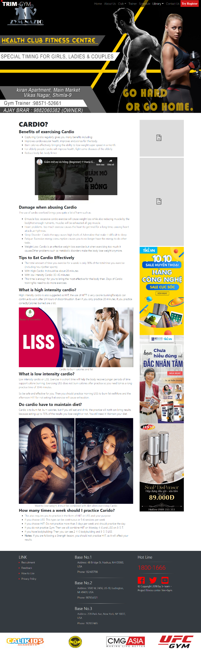

Example 2: MUSCLE

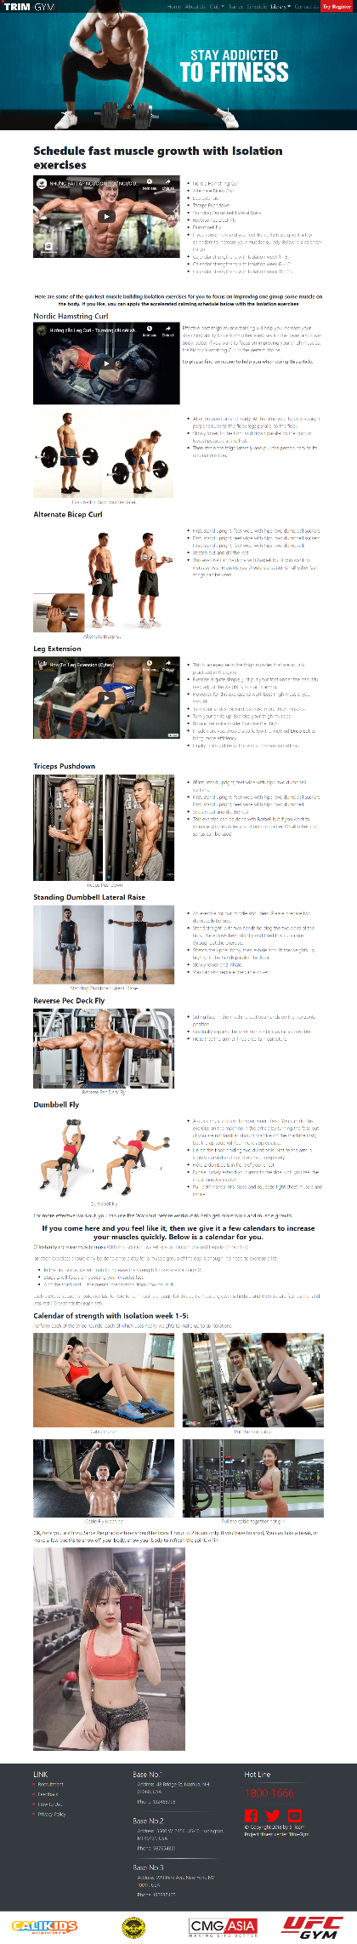

Example 3: NUTRITION

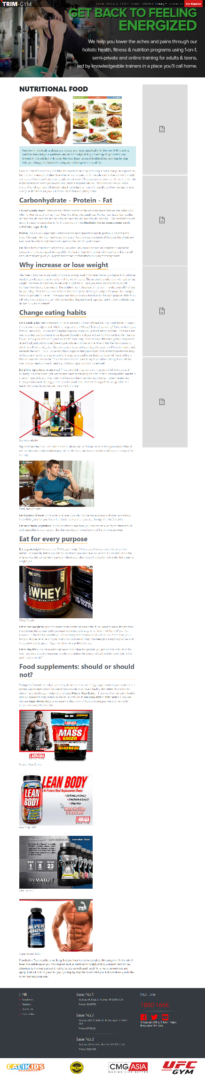

Example 4: GALLERY

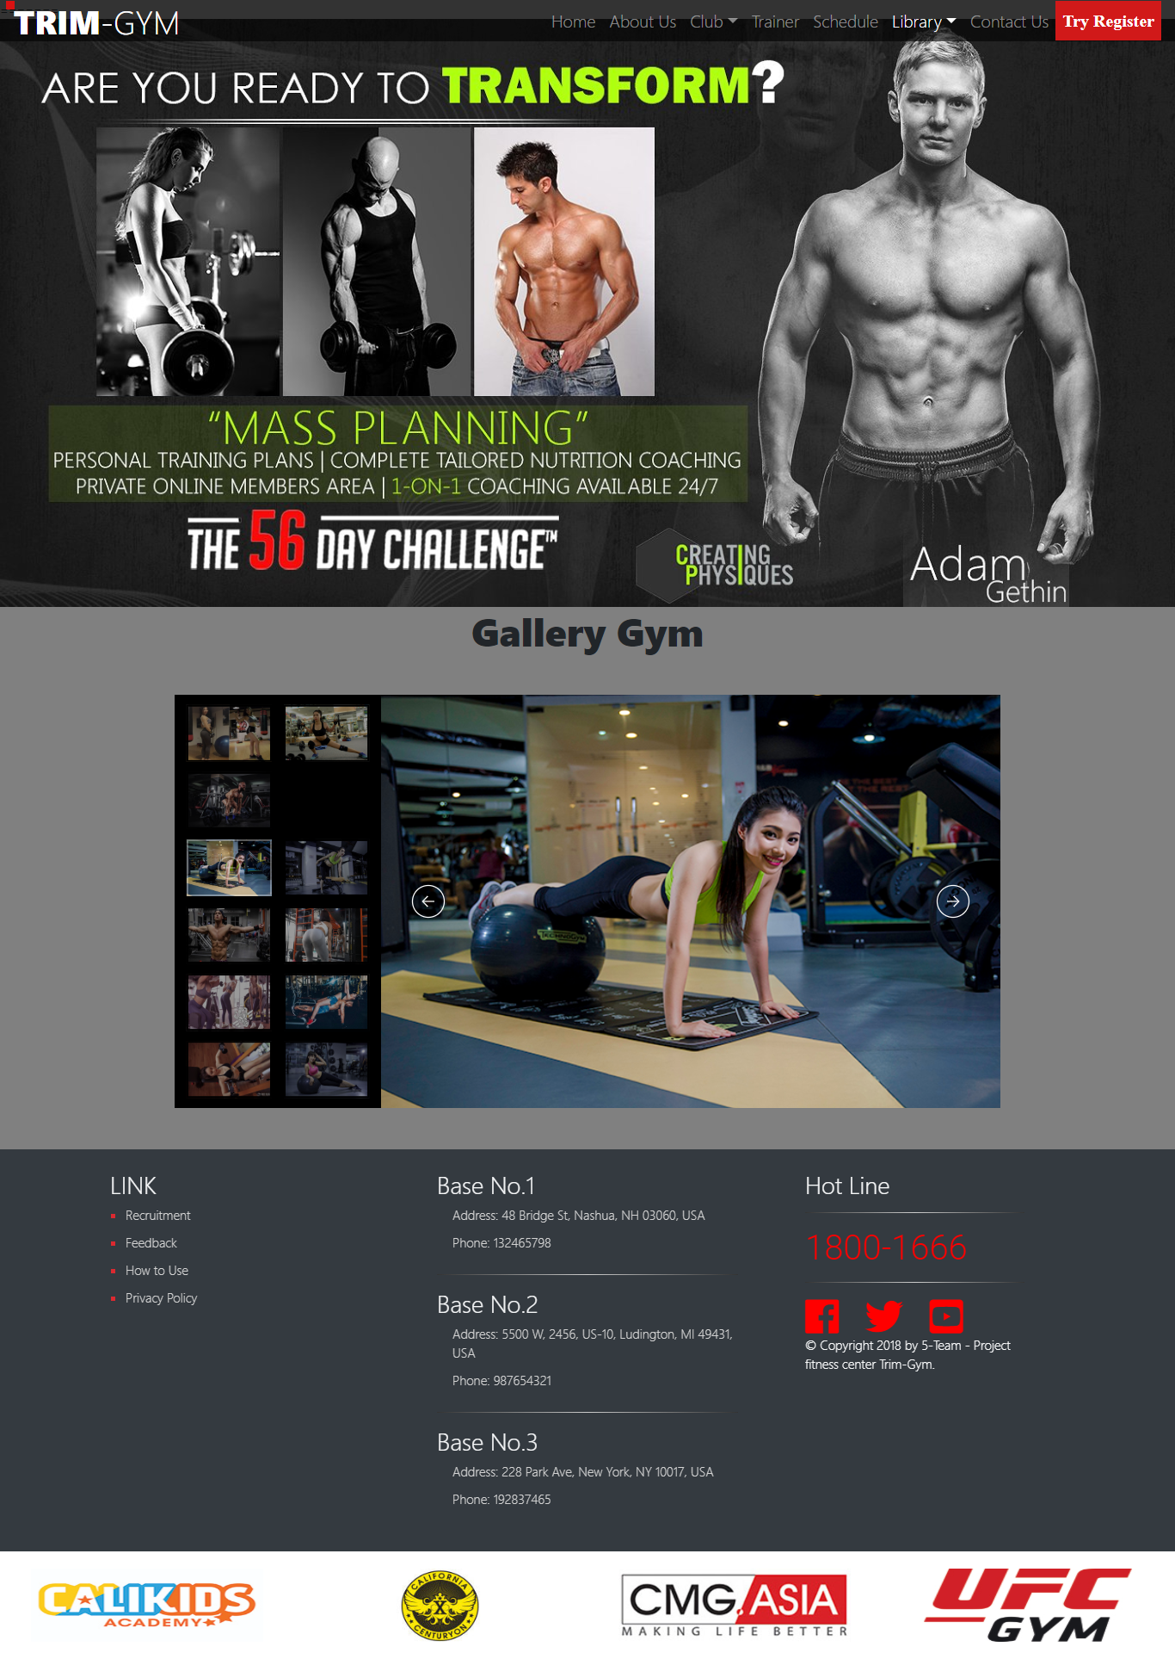

## UI 6 – CONTACT US

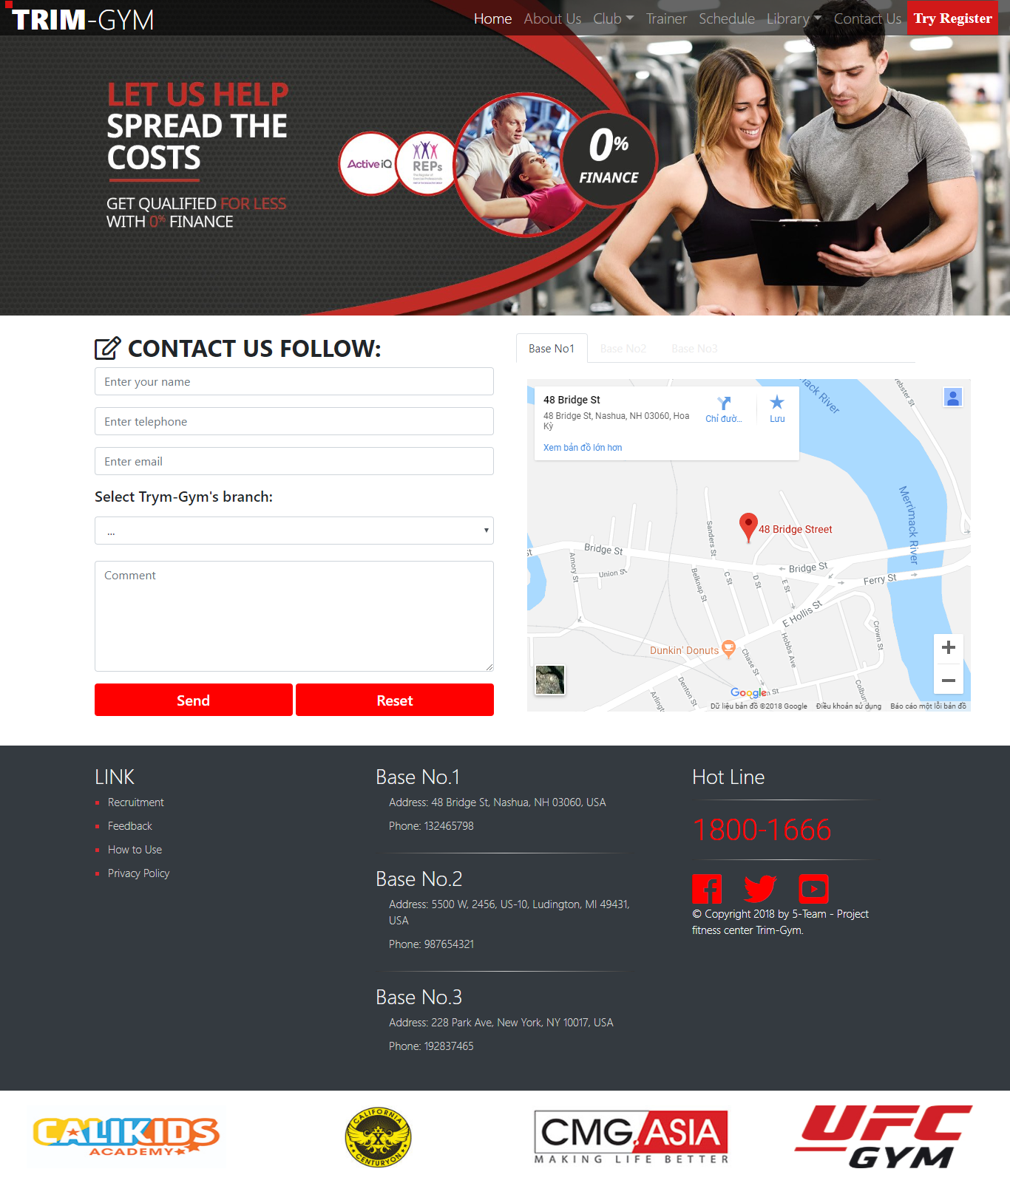

## GUI 7 – TRY REGISTER

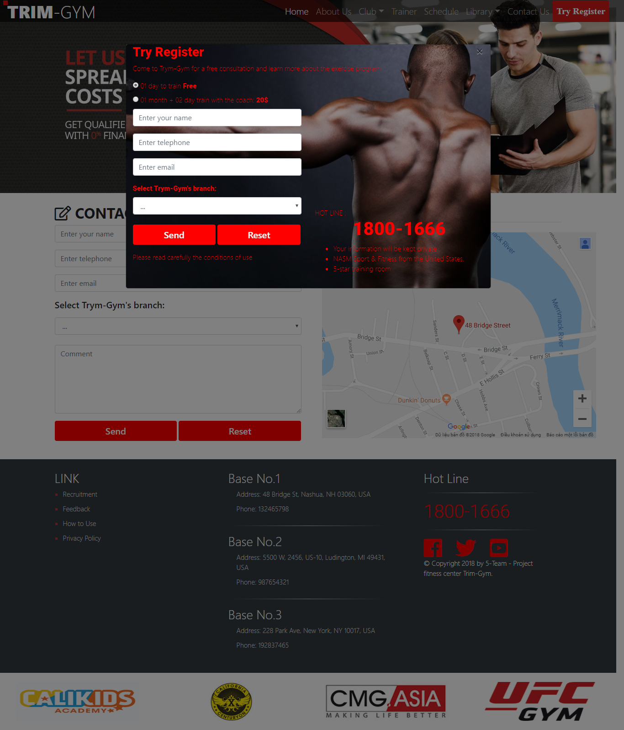

## GUI 8 – FEEDBACK

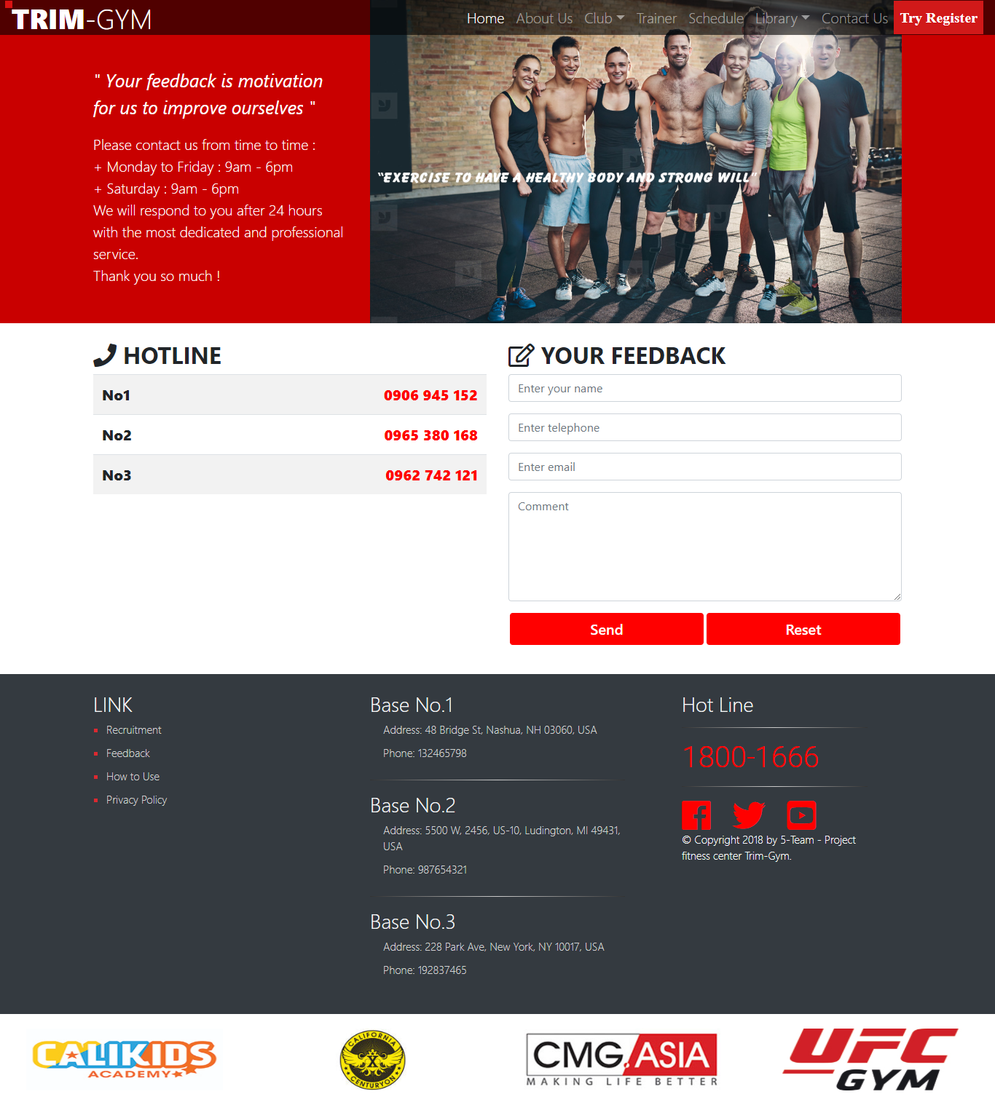

# Summary

With the requirements of the project, the team needs to build a website with many pages that containing the necessary information, including 15 pages and assignment to project team members responsible for each page as bellow:

|  |  |  |  |
| --- | --- | --- | --- |
| **ID** | **Item** | **Details (Wiki)** | **Responsible** |
| 1 | Home Page | About the services of the center of the famous coaches and students | Hoang Van Quynh |
| 2 | About Us Page | Introduce the history of the center | Hoang Van Quynh |
| 3 | Club Page | Introduce the headquarters of the center | Hoang Van Quynh |
| 4 | Trainer Page | Introduce famous trainers and celebrities who have practiced here | Hoang Van Quynh |
| 5 | Schedule Page | Introduce training schedule | Nguyen Thanh Tung |
| 6 | Library Page | Introduce Cardio, Muscle, Nutrition and Gallery of Trym-Gym | Duong Tuan Linh |
| 7 | Contac Us Page | Customers send information for consultation | Duong Tuan Linh |
| 8 | Try Register Page | Customers register trial | Nguyen Thanh Tung |
| 9 | Recruitment Page | Recruit relevant positions | Nguyen Thanh Tung |
| 10 | Feedback | Customer messages | Nguyen Thanh Tung |